|  |
| --- |
|  |

Guide for Testing

Best Practices for Optimal Performance of MorphoFace Version 2.0.1

Confidentiality Rules

All information presented within this document is owned by IDEMIA.

This document has been assigned a 2nd category classification level. This implies that the information contained within is considered to be confidential and cannot be freely distributed outside of IDEMIA.

The statement “Reproduction and disclosure prohibited” appears on each and every page.

Reproduction prohibited means that this document may not be reproduced by any means including photocopy or photographs, without written permission from IDEMIA. Reproduction is limited to the number of working copies needed by the people concerned with this document for the use stated in the contract existing between IDEMIA and the outside recipient.

Disclosure prohibited means that any person outside of IDEMIA who receives this document is not allowed to transmit any of the information contained within in any form whatsoever: orally, by Processor Unit network, telephone, slides, photographs, video tape etc. to any person not directly concerned with the information contained in the document. Disclosure is limited to persons concerned with this document for the use stated in the contract existing between IDEMIA and the outside recipient.

Table of Contents

Introduction 4

Purpose and Scope 4

About This Document 4

MorphoFace Specification 4

Key Features and Setting 8

Manual Trigger 8

Automatic Trigger 8

Duplicate Detection 9

Anti-Spoofing (Beta release) 9

Configurable Display and Live Video 9

Single Face Capture 10

Multi-Face Capture 10

Face Capture Rate 10

Introduction

Purpose and Scope

This document contains Best Practices for Optimal Performance of MORPHOFACE Version 2.0.1.

This document offers detailed information to ensure optimal operational performance for the MorphoFace for land and air entry border environments. This document was put together using requirements and specification during design, implementation, and testing. The scope of these Best Practices, although general enough for many operational use cases, has some aspects that are specific to the land and air requirements as they are currently being interpreted.

About This Document

The structure of this document is as follows:

* Section 1: Introduction

This section introduces the document and describes the purpose and scope of the Guide for Testing, as well as specifications

* Section 2: Key Features and Setting

This section details the manual and auto-capture triggers that are present in the camera to initiate face capture. The section also describes the features such as spoofing, internal matching, and the configurable display and live video, as well as single and multi-face capture.

MorphoFace Specification

**Camera field of view and distances**

Horizontal cameras field of view: 78°

Vertical cameras field of view 62°

General lighting lux measurement in capture zone 250-1500 Lux

Convergence point of cameras axes 2.62 ft.

Camera resolution at 4 ft. (number of pixels between eyes) 80 pixels

Optimum distance between passenger and MorphoFace for face acquisition: 3 ft.

Usable distance between passenger and MorphoFace for face acquisition: 1 - 5 ft.

Optimum height of the MorphoFace device for face acquisition: 3 ft.

**Ergonomics**

It is recommended to:

* Add physical obstacles between MorphoFace and passenger, to help passenger to go to the position for best acquisition
* Add footprints or line on the floor to invite passenger to stand on this marks

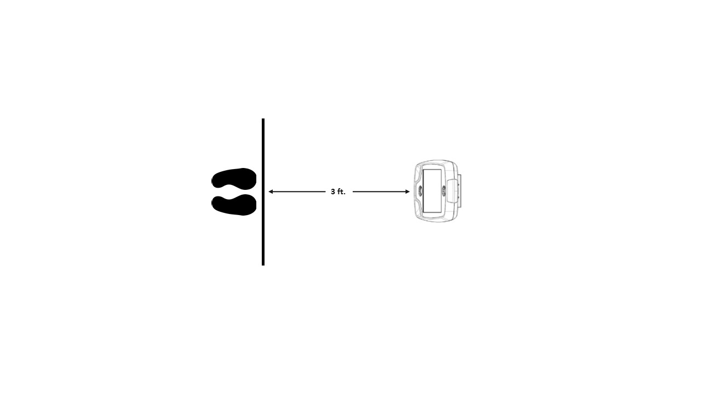

Singe Face capture layout

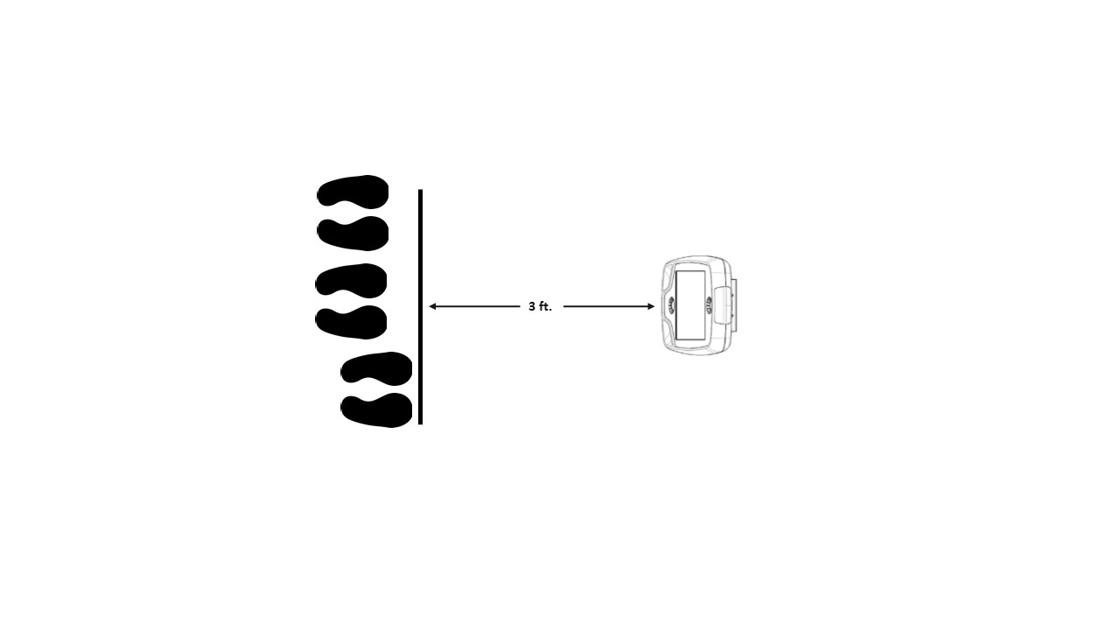

Multi-Face capture layout

* Display live video feedback available on the MorphoFace screen in order to help passenger to be into the acquisition area
* Capture faces using optimum height and acquisition distance of 3 ft.

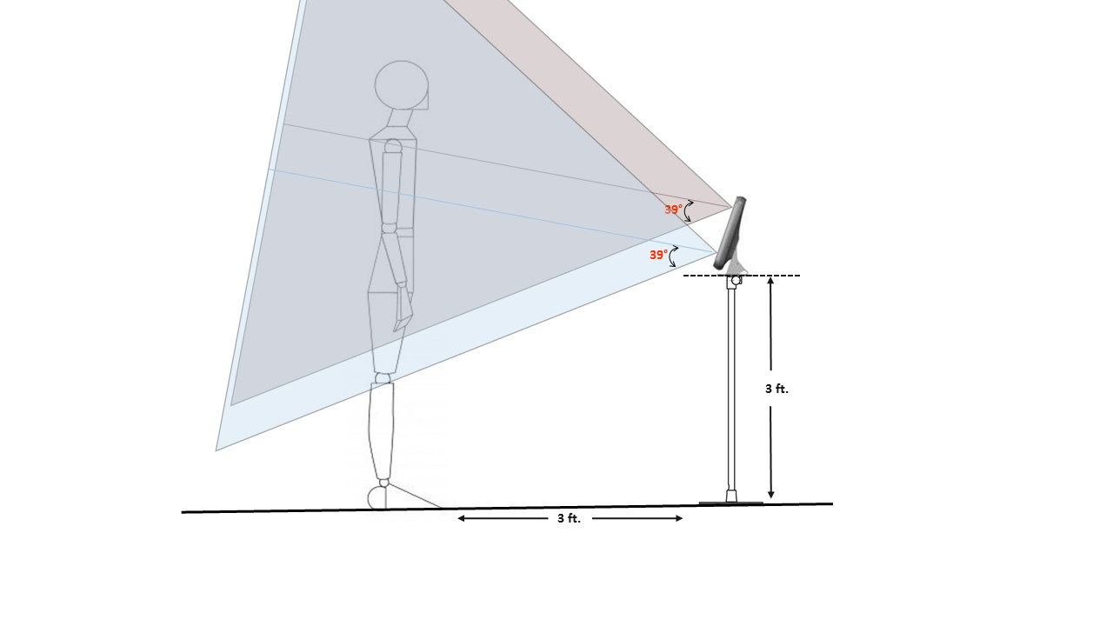

Optimum height and distance for face acquisition

Key Features and Setting

The MorphoFace device is able to work in either manual (e.g. capture started with press of button) or automatic mode (e.g. capture triggered by motion in front of the device). The user is able to switch between manual and automatic modes in the configuration file (*D:\MorphoFace\conf\MorphoFace.properties*) only. Whenever the trigger mode is changed, the software should be exited and restarted.

Manual Trigger

To enter manual capture mode, navigate to the configuration file for the device, and make the following change. ‘trigger.mode = BUTTON’.

In manual mode, there is a ‘Start Capture’ button present in the application window. The agent can begin the capture process by pressing the ‘Start Capture’ button. Once the ‘Start Capture’ button is pressed, the camera tries to detect the face for a quality image.

Automatic Trigger

In automatic mode, capture begins when a passenger enters the capture zone.

To enter automatic capture mode, navigate to the configuration file for the device, and make the following change. ‘trigger.mode = PRESENCE’. In automatic mode, capture begins when a passenger enters the capture zone.

Duplicate Detection

During face capture, multiple frames of the subject are acquired. Also, there may be a scenario where a passenger that has already been captured by the camera, is captured again. In both of these cases, we want to ensure that we are forwarding only one image for verification, and that is the best image. Our duplication matching feature allows us to detect an unique face before it is forwarded for verification. A folder of all images forwarded for verification are stored in the duplicates folder and later used by our internal matching algorithm (*D:\MorphoFace\enroll\duplicates*). By default, the number of images that can be stored in the duplicate folder is 500. This can be changed in the configuration file by changing the value for the ‘enroll.dup.limit’ variable.

Anti-Spoofing (Beta release)

Anti-spoofing is a feature that allows the camera the ability to automatically distinguish between a real face that is presented to the camera and an artificial face that is presented to the camera. If a photograph (2D) is used in an attempt to spoof the camera, our algorithm has the ability to detect this. As a result, the face will be captured, but will not be forwarded or sent for verification. All attempts of image capture via spoofing are stored in the ‘\captures’ folder and have ‘SPOOF’ appended to the file name. In the scenario where there are artificial faces and real faces in front of the camera (e.g. multi-face), only the real faces will be captured and forwarded for verification.

Configurable Display and Live Video

A new key feature is the ability to enable/disable the live video feed. In order to change whether the live feed is displayed, navigate to the configuration file for the device, and change the value for the ‘capture.live.video.mode’ variable. The user is also able to use the ‘Live Video On/Off’ button that is located in the application console. If the live video is enabled, there are two overlay options available (e.g. EnableWithOverlay or EnableWithEllipseOverlay). Anytime the live video feed is changed, the display service should be restarted.

Single Face Capture

Single Face Capture has the ability to use both a manual trigger and automatic trigger for capture. To initiate single face capture, navigate to the configuration file for the device, and make the following change. ‘capture.mode = FACE’.

Multi-Face Capture

Our multi-face capture mode is robust in its ability to capture multiple faces within the capture zone. To initiate multi-face face capture, navigate to the configuration file for the device, and make the following change. ‘capture.mode = MULTI_FACE’.

Face Capture Rate

Capture times are configured with upper and lower bounds. The ‘capture.min_attempts=n’ configuration is used to set the minimum capture time or rate. The ‘capture.timeout=n’ configuration is used to set maximum capture time.